Julio Santos

Laboratory 10

Electrocardiography

Purpose:

Electrocardiography is the study of the electrical activity of the heart. Electrocardiograms EKG are graphical records that measure the change in the electrical activity of the heart. An ECG records these impulses to show how fast the heart is beating, the rhythm of the heart beats (steady or irregular), and the strength and timing of the electrical impulses as they move through the different parts of the heart.

Procedures:

1. Open the Labscribe3program by clicking on the Labscribe3 icon on the desktop. As soon as the program opens, you should see a window pop-up that says “Hardware found IWX214:2008-1-24,”
2. Change the settings according to what is needed. (file “human heart”, “EEG-Heart sounds”)
3. Apply the following patches on:
   * the black (-1) lead is attached to the right wrist,
   * the red (+1) lead is connected to the left ankle,
   * the green (Cor ground) lead is connected to the right ankle
4. Instruct the subject to sit quietly with their hands in their lap. If the subject moves, the ECG trace will move off the top or bottom of the screen. If the subject moves any muscles in the arms or upper body, electromyograms (EMGs) from the muscles will appear on the ECG recording as noise.
5. Start recording for about a minute for results.
6. When you have a suitable trace, type <Subject’s Name> Lead II in the Mark box to the right of the Mark button. Press the Enter key on the keyboardafter the recording has started to attach the comment to the data
7. . When the mouse is on top of this tab, it will say “Half Display Time.” Clicking this tab will spread out your ECG patterns for step 11.If you overdo that last step, reverse it by clicking on the tab that looks like double pyramids (“Double Display Time”) just to the right of the Half Display Time tab.
8. Record for approximately one minute and then click Stop to halt recording. Label on set of the five ECG waves (P, Q, R, S andT).

Results:

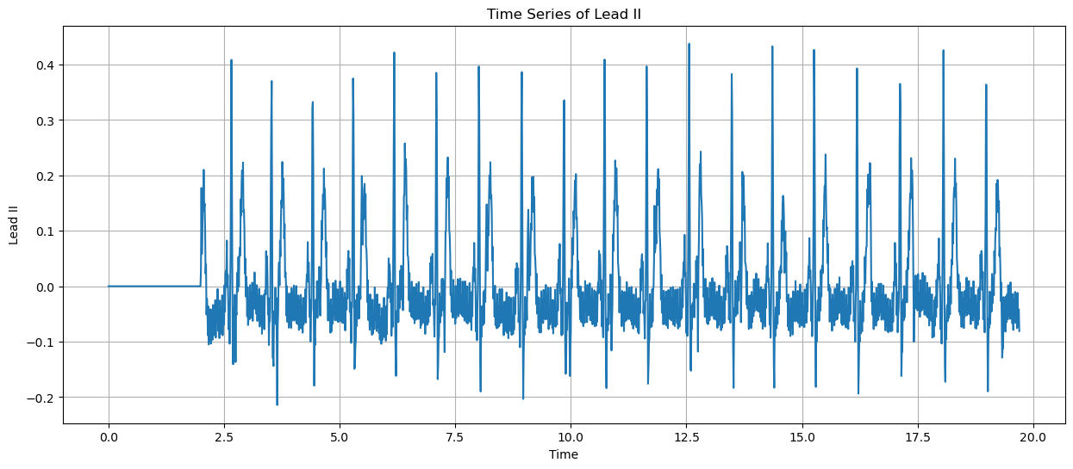

Discussion:

In this lab we measured the EKG of our heart's rhythm and made sure everything looked normal. We had to point out the P, R, and T. P lets us know the atrial depolarization, R is the ventricular depolarization, and T is the ventricular repolarization. The once we left out were Q and S, which are also part of the ventricular depolarization. For us to be able to get a better understanding, we took about 10 seconds out of the minute that we sampled.

Conclusion:

In conclusion I now have a better understanding of what Electrocardiography is. I also can identify the depolarization and repolarization of an ECG as well. Also, that the ECG shows records of how fast our heart beats and the constant changes can show how something can be potentially wrong as that really shouldn’t be the case on a normal ECG, but they show up in different sizes and variations.